Database Programming with SQL

14-1: Intro to Constraints; NOT NULL and UNIQUE Constraints

Practice Activities

Objectives

•

•

•

•

•

•

Define the term "constraint" as it relates to data integrity

State when it is possible to define a constraint at the column level, and when it is possible at

the table level

State why it is important to give meaningful names to constraints

State which data integrity rules are enforced by NOT NULL and UNIQUE constraints

Write a CREATE TABLE statement which includes NOT NULL and UNIQUE constraints at the

table and column levels

Explain how constraints are created at the time of table creation

Vocabulary

|  |  |
| --- | --- |
| Unique constraint | Every value in a column or set of columns (a composite key)  must be unique |
| Not null constraint | For every row entered into the table, there must be a value for  that column |
| Primary key | Constraint ensures that the column contains no null values and  uniquely identifies each row of the table |
| Check constraint | Specifies a condition for a column that must be true for each row  of data |
| references | Identifies that table and column in the parent table |
| Unique constraint(again?) | An integrity constraint that requires every value in a column or set  of columns be unique |
| Foreign key | Designates a column (child table) that establishes a relationship between a primary key in the same table and a different table  (parent table) |
| Table level constraint | References one or more columns and is defined separately from  the definitions of the columns in the table |
| constraint | Database rule. |
| Column level constraint | Database rule that references a single column |

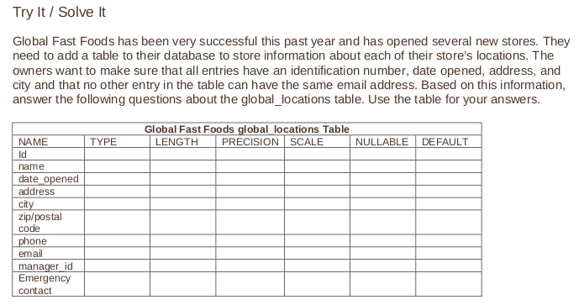1. What is a “constraint” as it relates to data integrity?

Constrangeri>importante ca sa nu introducem date aiurea, sau sa nu lasam liber un field care nu ar trebui sa fie null

2. What are the limitations of constraints that may be applied at the column level and at the table

level?

**Constraints referring to more than one column are defined at Table Level**

· **NOT NULL constraint must be defined at column level as per ANSI/ISO SQL standard.**

·**If word CONSTRAINT is used in a CREATE TABLE statement, I must specify constraint name. Also, that is why, Table level constraint must be user-named.**

3. Why is it important to give meaningful names to constraints?

**If a constraint is violated in a SQL statement execution, it is easy to identify the cause with user-named constraints.**

· **It is easy to alter names/drop constraint.**

·**Handling production issues may be faster with user-named constraints**

Deci e usor la debugging

4. Based on the information provided by the owners, choose a datatype for each column. Indicate

the length, precision, and scale for each NUMBER datatype.

5. Use “nullable” to indicate those columns that can have null values.

4 si 5 combinate>

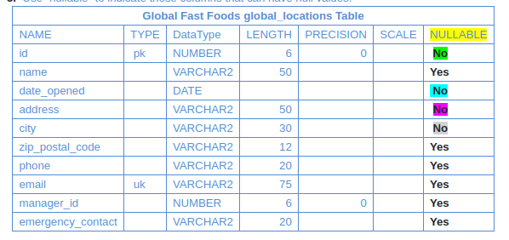

6. Write the CREATE TABLE statement for the Global Fast Foods locations table to define the

constraints at the column level.

**CREATE TABLE f_global_locations**

**( id NUMBER(6,0) CONSTRAINT f_gln_id_pk PRIMARY KEY ,**

**name VARCHAR2(50),**

**date_opened DATE CONSTRAINT f_gln_dt_opened_nn NOT NULL ENABLE,**

**address VARCHAR2(50) CONSTRAINT f_gln_add_nn NOT NULL ENABLE,**

**city VARCHAR2(30)  CONSTRAINT f_gln_city_nn NOT NULL ENABLE,**

**zip_postal_code VARCHAR2(12),**

**phone VARCHAR2(20),**

**email VARCHAR2(75) CONSTRAINT f_gln_email_uk UNIQUE,**

**manager_id NUMBER(6,0),**

**emergency_contact VARCHAR2(20)**

**);**

7. Execute the CREATE TABLE statement in Oracle Application Express.

done

8. Execute a DESCRIBE command to view the Table Summary information.

>Describe f_global_locations

9. Rewrite the CREATE TABLE statement for the Global Fast Foods locations table to define the

UNIQUE constraints at the table level. Do not execute this statement.CREATE TABLE  f_global_locations

( id NUMBER(6,0) CONSTRAINT f_gln_id_pk PRIMARY KEY ,

name VARCHAR2(50),

date_opened DATE CONSTRAINT f_gln_dt_opened_nn NOT NULL ENABLE,

address VARCHAR2(50) CONSTRAINT f_gln_add_nn NOT NULL ENABLE,

city VARCHAR2(30)  CONSTRAINT f_gln_city_nn NOT NULL ENABLE,

zip_postal_code VARCHAR2(12),

phone VARCHAR2(20),

**email VARCHAR2(75) ,**

manager_id NUMBER(6,0),

emergency_contact VARCHAR2(20),

**CONSTRAINT f_gln_email_uk UNIQUE(email)**